HANOI UNIVERSITY OF SCIENCE AND TECHNOLOGY

School of Information and communications technology

Novel Reading Project

Subject: Software engineering

Group 17

*Hanoi,* *04, 2024*

Table of contents

Table of contents 1

1 Introduction 2

1.1 Objective 2

1.2 Scope 2

1.3 Glossary 2

1.4 References 3

2 Overall Description 4

2.1 Survey 4

2.2 Overall requirements 4

2.3 Business process 4

3 Detailed Requirements 5

3.1 Use case 1 6

3.2 Use case 2 7

4 Supplementary specification 8

4.1 Functionality 8

4.2 Usability 8

4.3 Reliability 8

4.4 Performance 8

4.5 Supportability 8

4.6 Other requirements 8

# Introduction

## Objective

This project aims to develop a platform designed for novel lovers to read and share stories. Users can access the platform through free accounts or upgrade to VIP memberships, creating a flexible and inclusive reading experiences.

## Scope

This project aims for people that are interested in reading novels online, as well as people that wants to share novels for other people within the platform.

## Glossary

User Authentication: the process of verifying if an account exists in the user database either for the log in or registering activity.

# Overall Description

## Survey

*The Project involves three main actors interacting with the system:*

1. User: User are people who are interested in using the website to read their novels online. They can do many things on the website such as add new novels to their favorite list, search for a particular novel, read the novel, rate a novel or comment on a novel.
2. VNPAY system: It plays a critical role in executing transactions between user and the Novel website. Whenever a user want to upgrade to VIP membership, they are asked to perform a transaction on VNPAY.
3. Administrator: Admins are responsible for managing users, items in the database.

## Overall requirements

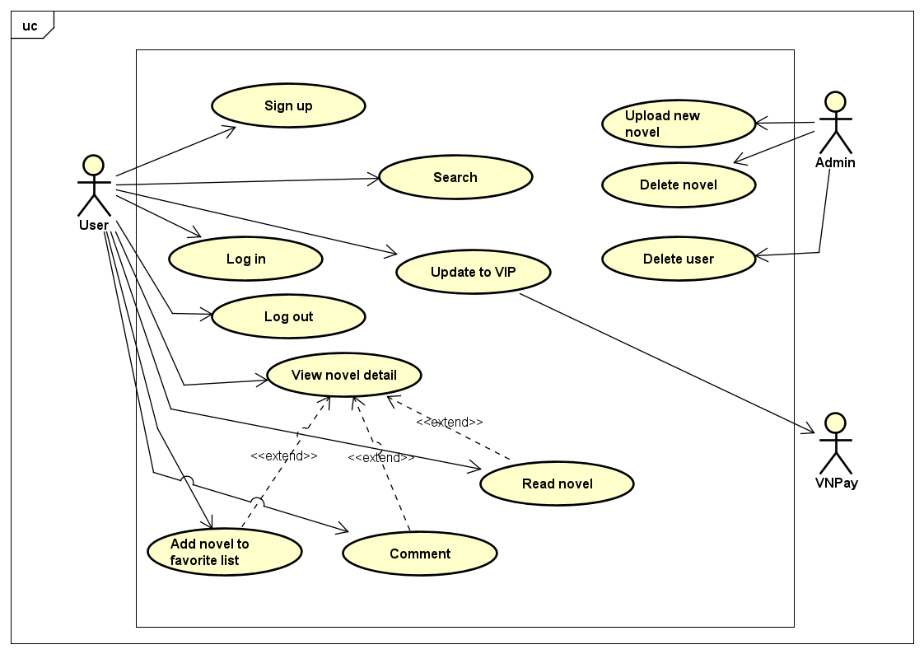

## Business process

### The overall process

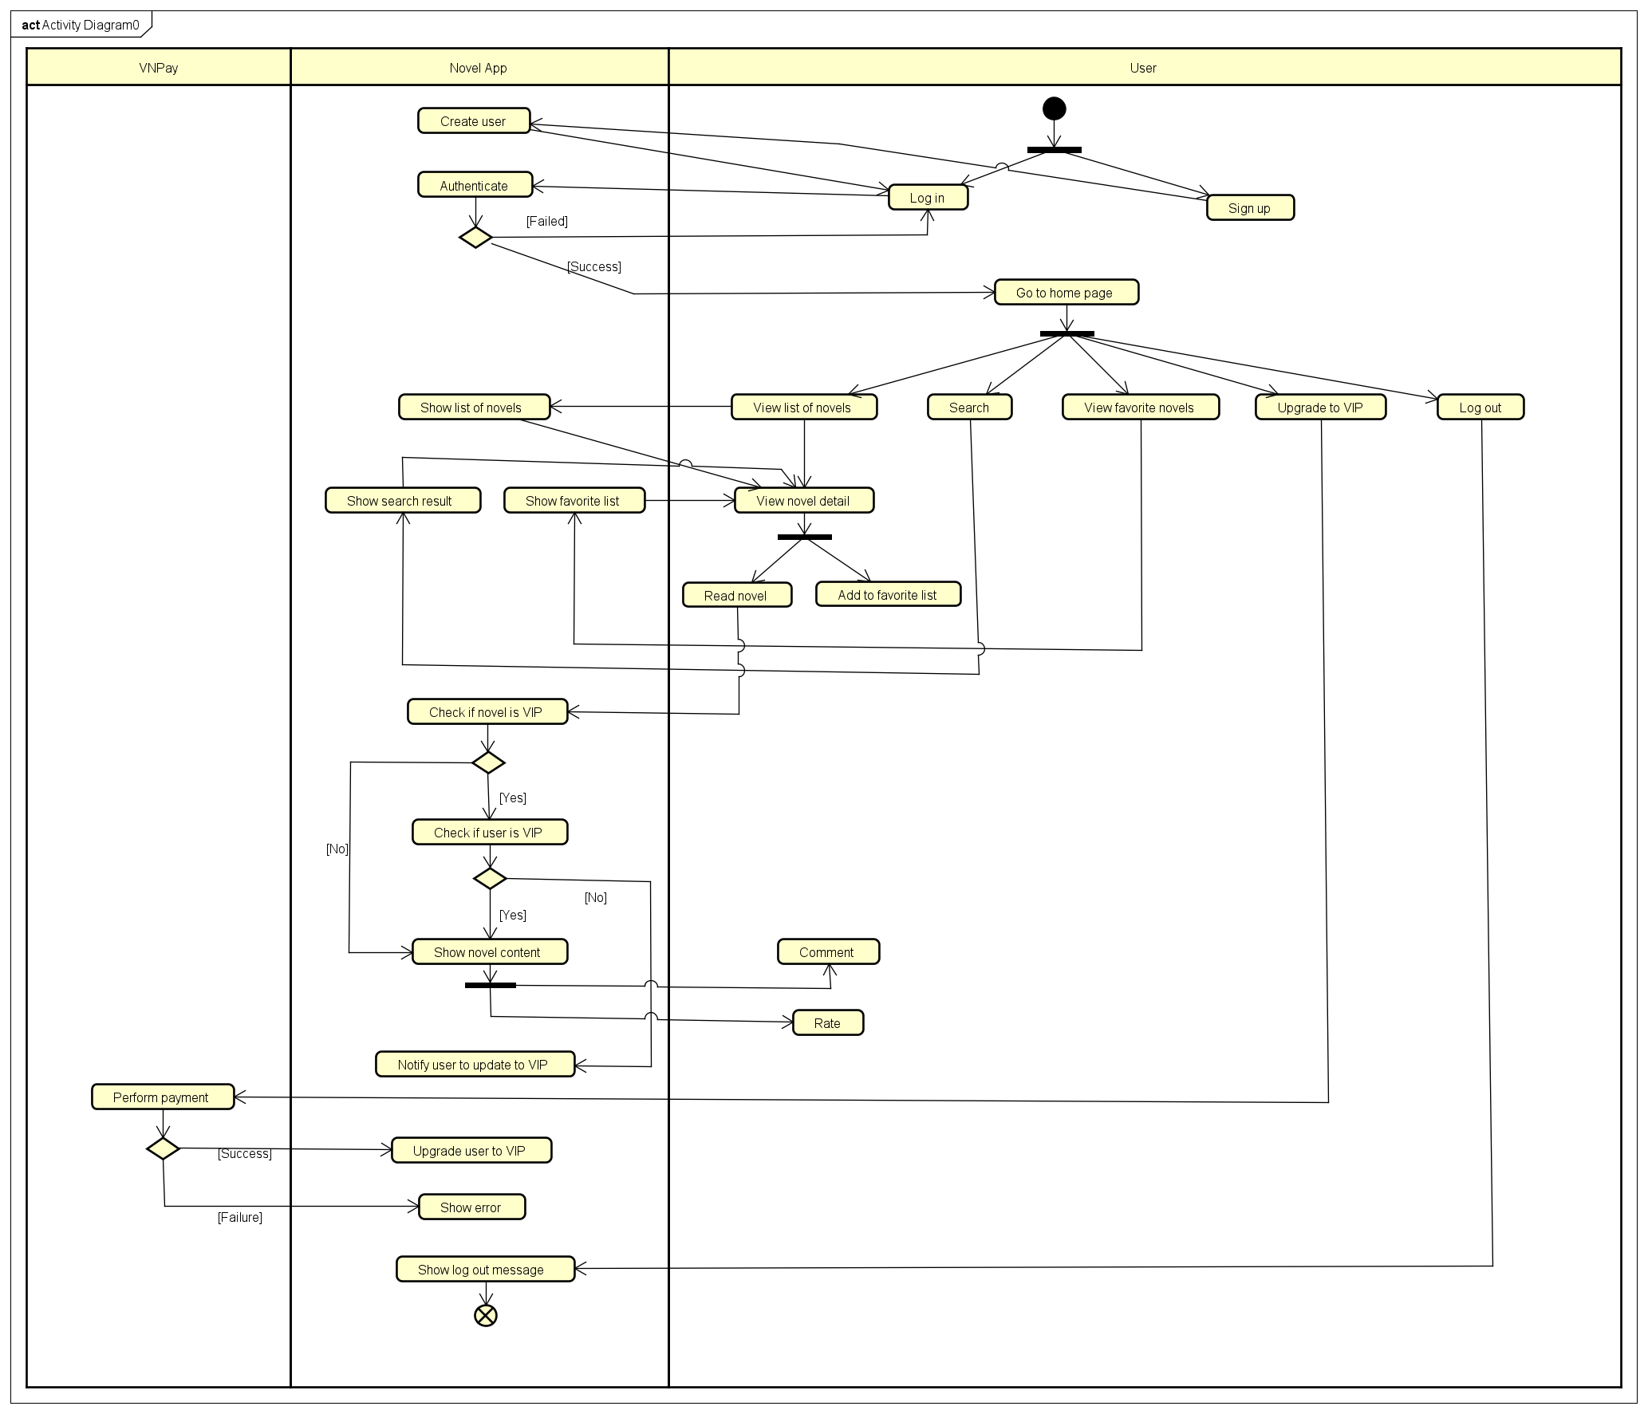

### Process details

* User authentication

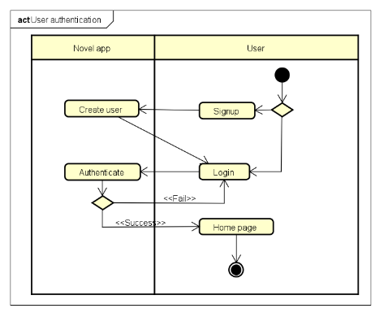

* Home page control

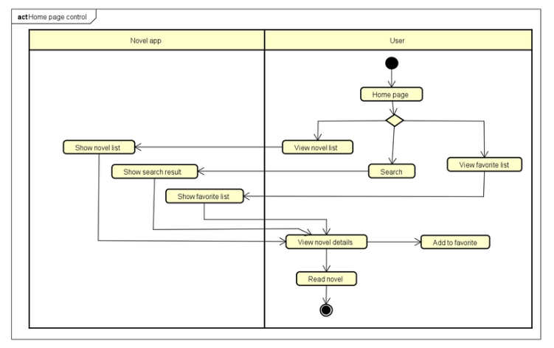

* Read novel

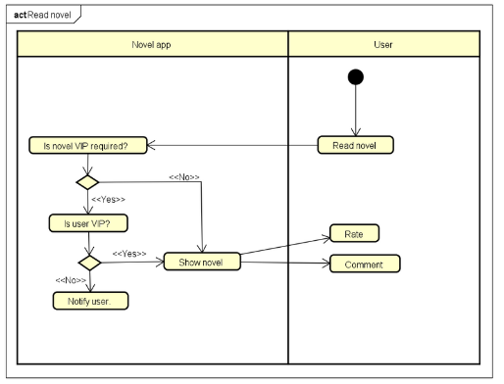

* Log out

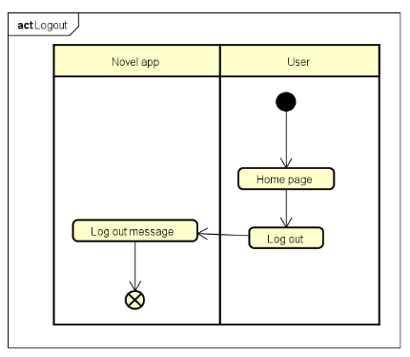

# Detailed Requirements

## Use case 1

|  |  |  |  |  |  |  |  |  |
| --- | --- | --- | --- | --- | --- | --- | --- | --- |
| **Use Case "Login**"  *1. Use case code:* UC001  *2. Brief Description*  This use case describes the interaction between User and Novel website when user wants to log in to the system using their account.  *3. Actors*  User  *4. Preconditions:* The Login page is loaded by any means.  *5. Basic Flow of Events*  Step 1. User write in username and password then click Login  Step 2. Novel web attempts to authenticate the account  Step 3. Novel web shows the home page with the logged account  *6. Alternative Flows*   |  |  |  |  | | --- | --- | --- | --- | | **Location** | **Condition** | **Action** | **Resume location** | | Step 2 | The information doesn’t match | Web tells user that they have typed in wrong information | Return to step 2 |   *7. Input*  *8. Output*  *9. Post-conditions* |

## Use case 2

|  |  |  |  |  |  |  |  |  |  |  |
| --- | --- | --- | --- | --- | --- | --- | --- | --- | --- | --- |
| **Use Case "Sign Up**"  *1. Use case code:* UC002  *2. Brief Description*  This use case describes the interaction between User and Novel website when user wants to register a Novel account.  *3. Actors*  User  *4. Preconditions*  The Sign up page is loaded by any means.  *5. Basic Flow of Events*  Step 1. User write in their new username and password and click Sign Up  Step 2. Novel web attempts to identify existing accounts  Step 3. Novel web proceeds to the Login page  *6. Alternative Flows*   |  |  |  |  |  | | --- | --- | --- | --- | --- | | **No.** | **Location** | **Condition** | **Action** | **Resume location** | | 1 | Step 2 | Account exists in the database | Show errors | Return to step 2 |   *7. Input*  *8. Output*  *9. Post-conditions* |

## Use case 3

|  |  |  |  |  |  |  |  |  |  |  |  |  |  |  |  |
| --- | --- | --- | --- | --- | --- | --- | --- | --- | --- | --- | --- | --- | --- | --- | --- |
| **Use Case “Read Novel”**  *1. Use case code:* UC003  *2. Brief Description*  This use case describes the interaction between User and Novel website when user wish(es) to read a novel.  *3. Actors*  User  *4. Preconditions*  User is in the Home page with a logged account.  *5. Basic Flow of Events*  Step 1. User select a novel card  Step 2. The web then show detail of the novel to the user  Step 3. User choose option Read to read the novel  Step 4. The web then check if the novel is a VIP item or not  Step 5. The web then check if the user is a VIP member or not  Step 6. The web then show the novel’s content for user to read  *6. Alternative flows*   |  |  |  |  |  | | --- | --- | --- | --- | --- | | **No** | **Location** | **Condition** | **Action** | **Resume location** | | 1 | At step 4 | If the novel is a VIP item | Web continues to check if user is a VIP member | At step 5 | | 2 | At step 5 | If the user is not a VIP user | Web asks user to upgrade to VIP member to read the novel | At step 2 |   *7. Input data*  *8. Postconditions* |

## Use case 4

|  |  |  |  |  |  |  |  |  |
| --- | --- | --- | --- | --- | --- | --- | --- | --- |
| **Use Case “Upgrade to VIP”**  *1. Use case code:* UC004  *2. Brief Description*  This use case describes the interaction between Novel website, user and VNPay system when the user wants to upgrade to VIP membership.  *3. Actors*  Customer  VNPay  *4. Preconditions*  User clicked on the Upgrade to VIP button.  *5. Basic Flow of Events*  Step 1. The website displays the invoice  Step 2. User asks to pay the invoice  Step 3. Novel software redirects to VNPay with payment information  Step 4. VNPay notifies the transaction result  Step 5. The website saves the payment transaction  Step 6. The website upgrades user to VIP membership  *6. Alternative flows*   |  |  |  |  | | --- | --- | --- | --- | | **Location** | **Condition** | **Action** | **Resume location** | | Step 4 | If the user cancels the transaction | The transaction is cancelled | Return to step 1 |   *7. Input data*  *8. Output data*  *9. Postconditions* |

# Supplementary information

## Functionality

- User: Read novel, search novel, rate novel, comment on novel, add novel to favorite list, upgrade to VIP membership.

- Administrator: manage user, manage novels

## Usability

- Operates 24/7, allowing new users to easily familiarize themselves.

## Reliability

- The software can resume normal operation within a maximum of 1 hour after anincident

## Performance

- Can serve up to 1,000 customers simultaneously without significantly reducing performance and can operate continuously for 300 hours without failure.

- The maximum response time of the software is 2 seconds under normal conditions or 5seconds during peak hours

## Supportability

- Currently only work on web browsers and supports VNPay as a transaction method for VIP membership upgrade.